|  |  |  |
| --- | --- | --- |
|  |  | **Information Sciences and Technologies**  **Golisano College of Computing and Information Sciences** |

hw 04b: Analyzing Web Sites with CRAP

# Overview

So, you've been web surfing for quite some time now, and you've undoubtedly found some pages that you like and others that you don't like. Sometimes, it's not so easy to really explain why. You now have a new vocabulary with which to describe your thoughts. Note: When this document has been completed, upload it to the dropbox using filename: **<Last_Name>.docx**.

# A. Site Evaluation

1. Follow this link using any browser:

**http://rochesterhomepage.net/**

1. Examine this site; at least the first page and a couple of links to sub-pages (pages that are part of the same site).
2. Summarize your opinions and the reasoning behind them:
   1. **Alignment:** The website continually uses it's text alignment to the left which seems look like the correct decision as the text looks clear and is readable.
   2. **Proximity:** All the content is evenly spaced and is perfectly readable and understandable.
   3. **Repetition:** The site has the same font all along, contains the same header and blue accents throughout its entirety.
   4. **Contrast:** The background contrast well with the font, makes it easily readable and is aesthetically pleasing.
   5. **Use of color:** The white, grey and blue background colors go along well with the black font.
   6. **Use of typography:** There’s a common font used throughout the whole website which makes it consistent and easy to read.
3. In myCourses/Discussions is a **Design Principles** topic. Tell the class your opinions on the design of **http:// rochesterhomepage.com/**.(HINT: You just wrote them in step 3). Each student must post thoughts individually.

# B. Personal Class Page

Your home page is found at *kelvin.ist.rit.edu/home/~abc1234/index.html*. Pick a color scheme for your own class page and describe it below. Describe your current, existing color scheme; it's probably very bland. In fact, you could do a screenshot and embed it below. Describe briefly how you would like to redesign this page in terms of what color(s) you would like to use for each element.

My current color scheme is only using a white background and black font. This is very bland and boring. I would like to utilize some light blue and grey accents throughout the website to make it look more appealing and aesthetic. I would use a light blue background, with the headers having a grey background and overall black font.

**Sketch for improved Layout:**

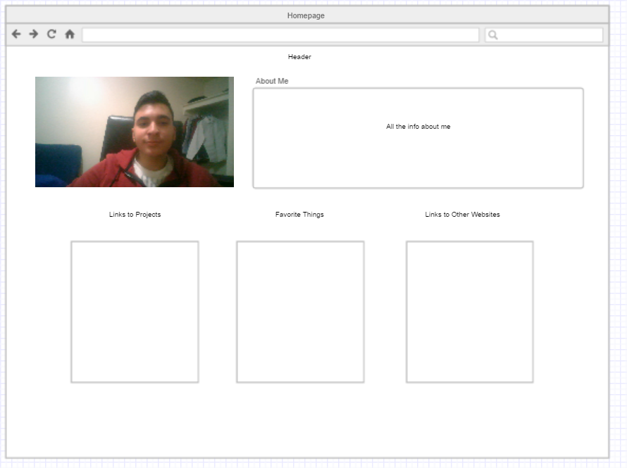

# Submission

When completed, upload this document to the dropbox using filename *<last_name>.docx*.

hw 04b: Analyzing Web Sites with CRAP

**Name:**

|  |  |  |
| --- | --- | --- |
| **Criteria** | **Weight** | **Score** |
| A.3 CRAP Analysis – rochesterhomepage.net | 30 |  |
| A.4 Discussion of site analysis posted to discussion | 20 |  |
| B. Personal home page shown as graphic or photo | 10 |  |
| B. Current color scheme for personal home page described | 10 |  |
| B. Discussion of improved color scheme. | 10 |  |
| B. Improved layout for personal home page site discussed | 10 |  |
| B. Graphic of improved personal home page included | 10 |  |
| **Total Points** | 100 |  |